Heroes of Pylomi

02/10/2019

Lead Analyst: LaShanti D. Jones



# Overview

There’s opportunity in female user market ages 15-229. Although rank lower in overall usage, they generate higher avg purchases.

## What are three observable trends based on the data?

1. The male user group generates the highest percentage of purchases

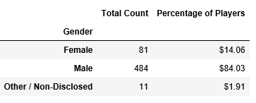

1. The female user group generates the highest average purchase per user.

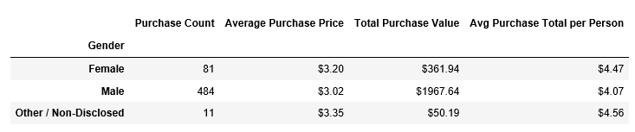

1. Oathbreaker, Last Hope of the Breaking Storm and Nirvana not only are the best-selling but the most profitable games on the list.

